# Introduction to AutoCAD 2014

AutoCAD 2014 is a 2-D and 3-D modeling software.

AutoCAD does not offer design and simulation validation.

So what is it good for?

Simple to complex 2-D and 3-D models.

Bill of material generation.

Electrical and pneumatic schematics.

# The AutoCAD Screen

* **Application Button** - This button displays commands for printing, saving, drawing utilities and other non-drawing tools.
* **Quick Access Toolbar** - This is for quick access to common commands like New, Open, Save, Plot
* **Filename** - The name of the current file you are working on.
* **Search Bar** - Search for text in your drawing or search the help files.
* **Ribbon** - The Ribbon has most of the commands/tools that you will use while you are working.
* **Tabs** - A series of Tabs make up the Ribbon (Home, Insert, Manage, etc) and organize the Tools into common groups.
* **Panels** - Contain a group of tools
* **Tools** - These are the icons that start the commands you use to draw, modify, etc.
* **Tool Tip** - If you hover your mouse over a tool, a tool tip will appear to give you more information.  Hold it longer for more info.
* **Drawing Space** - These is where you draw your designs.
* **Command line** - When you type a command, you will see it here. AutoCAD uses this space to 'prompt' you for information. It will give you a lot of information and tell you where you are in the command. **Watch this line while learning.**
* 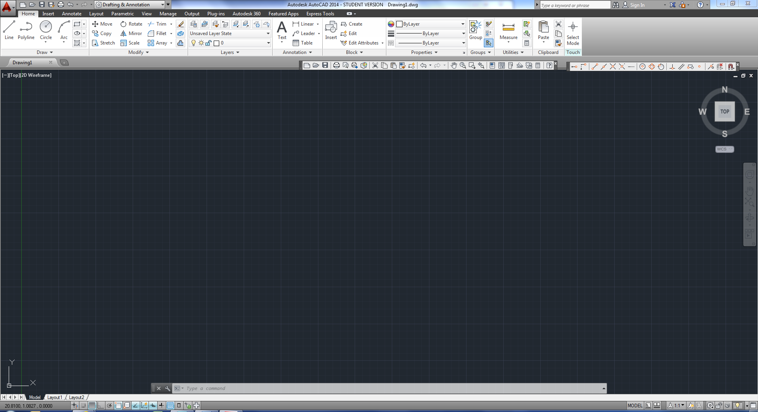**Status bar** - This allows to see and change different modes of drawing such as Ortho, Osnaps, Grid, Otrack, etc. You can right click this area to toggle between icons and text for this area.

# Creating a Drawing

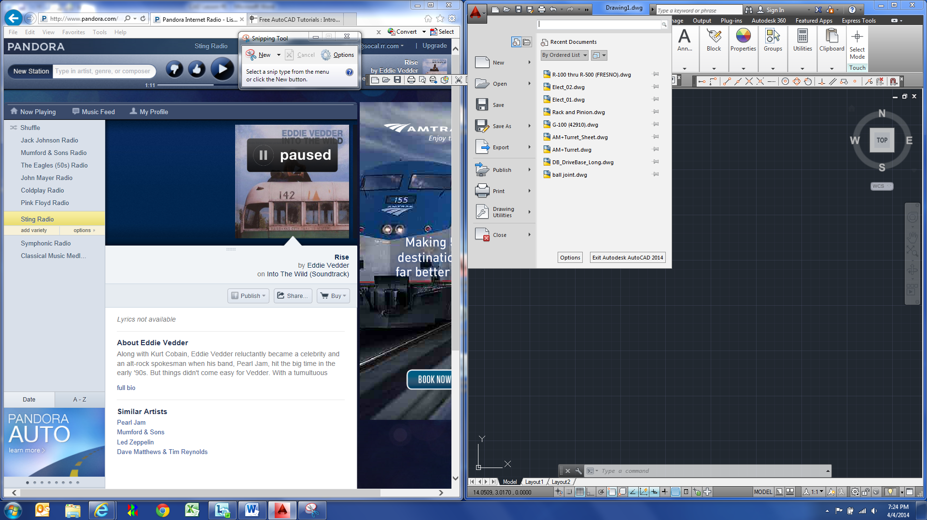

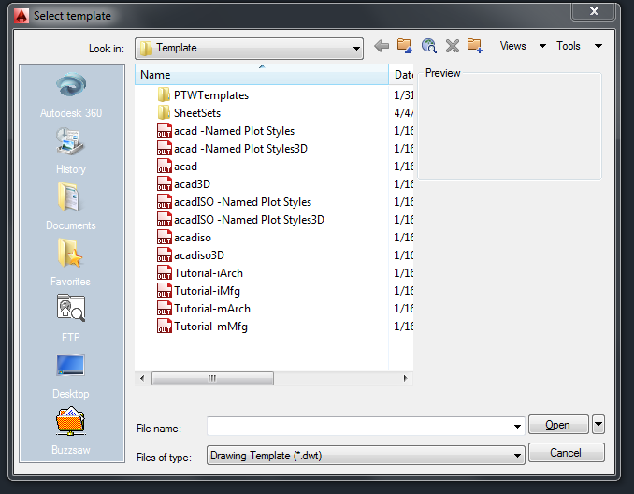

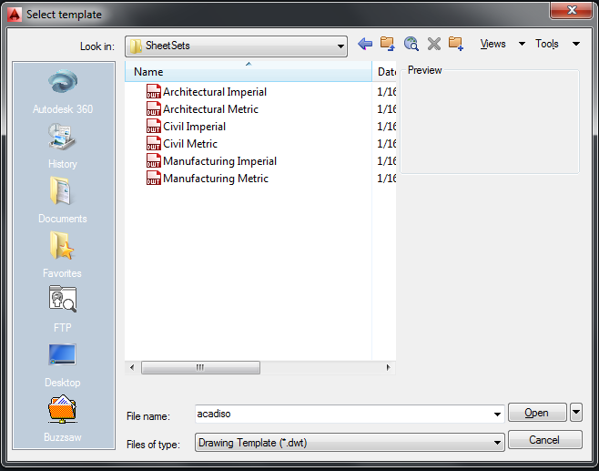

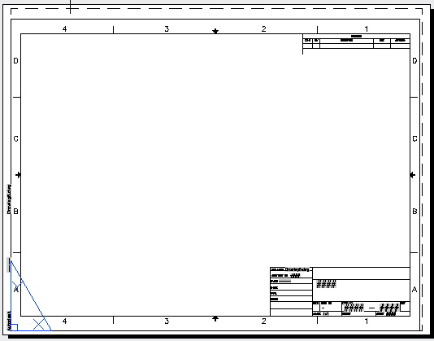

# Model Space vs. Paper Space

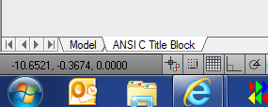

***Model Space***

* Model Space is where all drawing and design work is performed.
* Draw 1:1 (full-scale).
* Avoid placing text in Model Space.
* Utilize layers for different parts of model.

***Paper Space***

* Paper Space is used to create printed drawing.
* Use View Ports to create “views” of Model Space.
* Place text, dimensions, etc. in Paper Space.

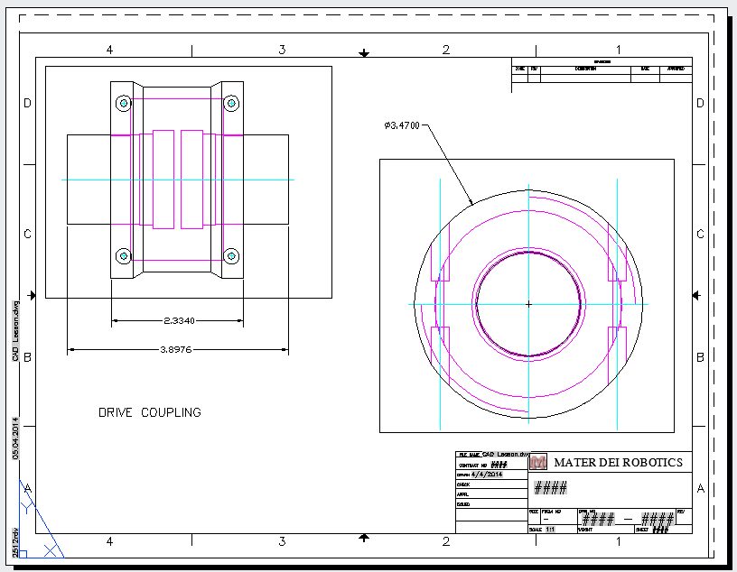

# Layers

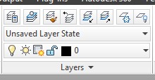

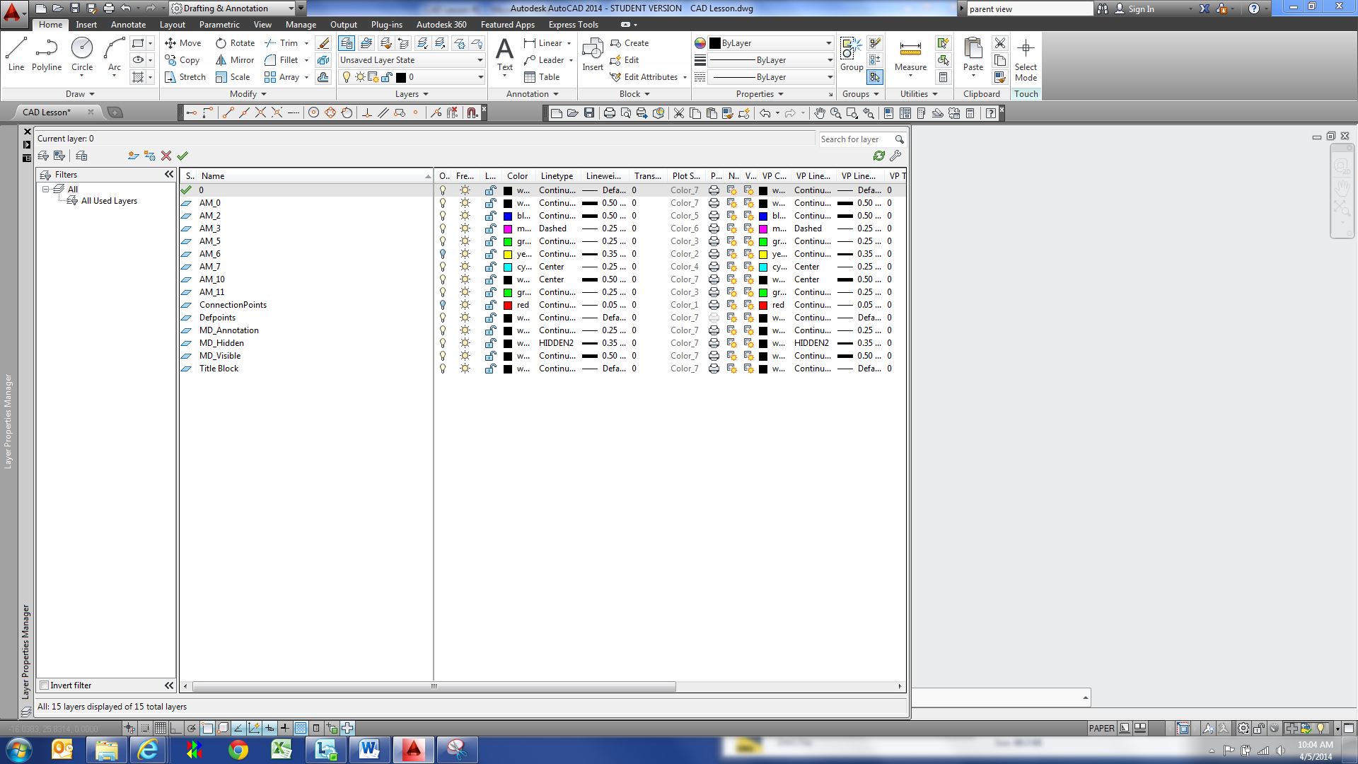

* Set line type, width and color.
* Specify how the line is to look when printed.
* Specify whether a particular layer prints or not.
* Permits model components to be separate by type.
* Layer “Defpoints” does not print out. Use this layer for design notes or comments to other that may view the drawing.

# Draw Commands

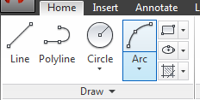

# Modify Commands

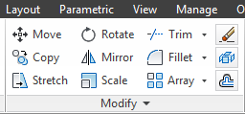

# Object Snap Settings



# Annotation (Text and Dimensions)

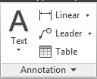

# Plot (Printing)

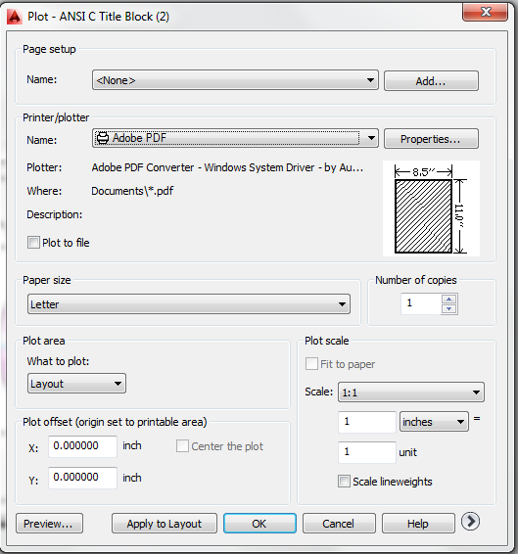

* Plot to printer or PDF.
* Specify what to plot.
* Specify sheet size.
* Specify plot area.
* Specify plot scale.